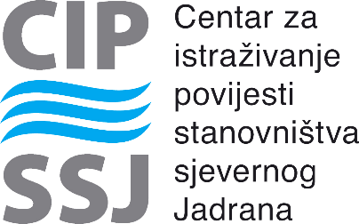

Centar za istraživanje povijesti stanovništva sjevernog Jadrana

Center for the Northern Adriatic Population Research

poziva vas na predavanje

invites you to a lecture entitled

***Love, Hate and Everything in between. Marriage in the Medieval Czech Lands at Urban and Ecclesiastical Courts***

Predavanje će održati

presented by

**Michaela Antonín Malaníková,** PhD, assistant professor

(Palacký University Olomouc)

u petak, 30. travnja 2021. u 11.30 u virtualnoj dvorani:

on Friday, April 30, 2021 at 11:30 in the virtual classroom at:

https://unipu-hr.zoom.us/j/96628334191

Meeting ID: 966 2833 4191

Predstavljanje će se održati na engleskom jeziku.

The presentation will be held in English.